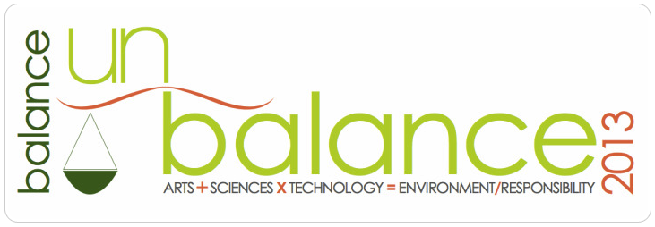
Transactions is a section in the printed journal Leonardo that publishes fully refereed papers in a fast track to disseminating key new results, ideas and developments in practice.
Papers are solicited matching the stated aims and scope of Leonardo, but are restricted to two pages of published material. A fast referee process is employed in which the result is restricted to ‘accept’ or ‘reject’. After a ‘reject’, the submission of a revised version will be treated as a new paper.
The announcement of results or developments in a Transactions paper will not exclude that work from subsequent publication in a full Leonardo paper. However, any such submission will be considered by Leonardo, in the normal way, as a new paper.
Papers that are correctly formatted and still under review can, with the author's permission, be published in Research Announcements. These will be available for download to registered users.
Papers should be submitted electronically in final camera ready form according to Leonardo’s guidelines. Incorrectly formatted papers will be rejected, so take great care. Refer both to the general editorial guidelines, and also to the specific guidelines for Transactions papers. The following template implement the guidelines: Two page template with illustrations
Download the template from: http://www.leonardo-transactions.com

DEADLINE: July 7, 2013.

Send to: ricardo.dalfarra@concordia.ca
CC: balanceunbalance2013@gmail.com
SUBJECT: Balance-Unbalance 2013 [ Leonardo Transactions submission ]

